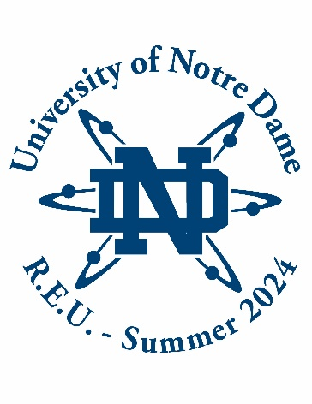  
 Research Experience for Undergraduates

UNIVERSITY OF NOTRE DAME

**2024 Summer Research Positions**

**For Sophomore and Junior**

**Undergraduate Physics Majors**

Areas of research include Astronomy, Astrophysics, Complex Systems/Biophysics, Condensed Matter Physics, High Energy Physics, Nuclear Physics, and Quantum Materials. Students will work closely with faculty and graduate students on a variety of current research projects.

**Dates: May 28 to August 4  
10-week Appointment***9 weeks in residence at Notre Dame, May 28 (arrival) to July 27 (departure)  
1 week online, July 29 – August 2*

**$6000 Stipend plus Housing**

On-campus housing, transportation allowance, and   
many group meals and events are provided.

**Application Deadline: February 19, 2024**

**Apply at physics.nd.edu/research/reu/**

To be eligible students should:

* Have a background in physics
* Have completed sophomore or junior year
* Be a U.S. citizen or permanent resident

All applications must be submitted electronically with a **letter** describing your interests and relevant background (math, computer, and research experience), a **transcript,** and **two faculty letters of recommendation**. Selection begins the day after the deadline so please be sure everything gets turned in prior to February 19, 2024!

For more information contact

Professor Umesh Garg or Kristen Amsler

[Umesh.Garg.1@nd.edu](mailto:Umesh.Garg.1@nd.edu) or [kamsler@nd.edu](mailto:kamsler@nd.edu)

574.631.2813

Physics REU Program

Department of Physics and Astronomy

University of Notre Dame

Notre Dame, IN 46556

Sponsored by the National Science Foundation and the University of Notre Dame.